## Patient Sequence diagrams

Register

Login patient

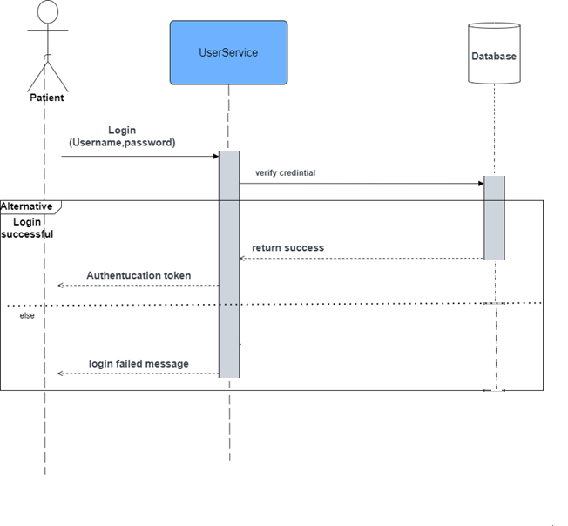

View doctor profile

Edit profile data

View Appointment History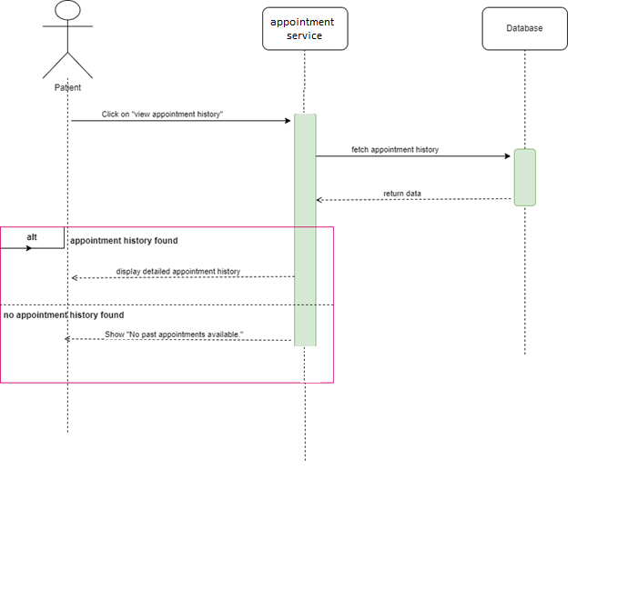

Search for a doctor

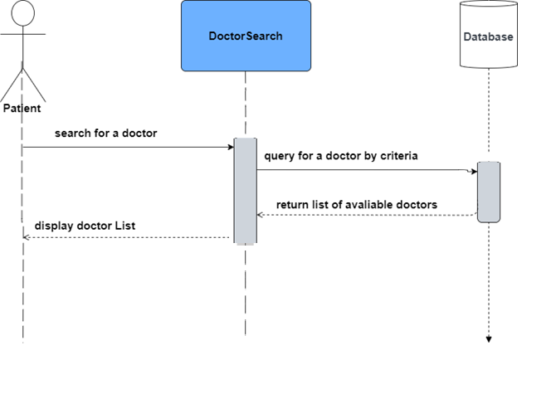

Patient appointment

Log out

